**LAB#6**

**Fundamentals of JQuery**

**OBJECTIVE:** Implement and Understand Fundamentals of JQuery.

**Student Task**

**Task 1: jQuery Fundamentals.**

Create a webpage that demonstrates different jQuery selectors and events by implementing an interactive FAQ (Frequently Asked Questions) section with the following requirements:

1. **Basic Structure:** 
   * Create at least 3 FAQ items (question-answer pairs)
   * Each question should be in a heading element (h3)
   * Each answer should be in a paragraph element initially hidden
2. **Functionality:** 
   * When a question is clicked, its corresponding answer should toggle (show/hide) with a slide animation. **Hint**: Toggle individual answers when questions are clicked (using class selector) using actions like **next()** and **slideToggle()**.
   * Add a "Show All" button that reveals all answers simultaneously. **Hint**: Show all answers (using ID selector) using actions like **slideDown()**.
   * Add a "Hide All" button that hides all answers simultaneously. **Hint**: Hide all answers (using ID selector) using actions like **slideUp()**.
   * Highlight the question when mouse enters (using element + class selector). **Hint**:

using actions like **mouseenter()** and **mouseleave()**.

1. **Requirements:** 
   * Answers should have a different background color than questions
   * Ensure the code executes only after the document is fully loaded
   * Use jQuery events (click) and effects.

* **CODE**

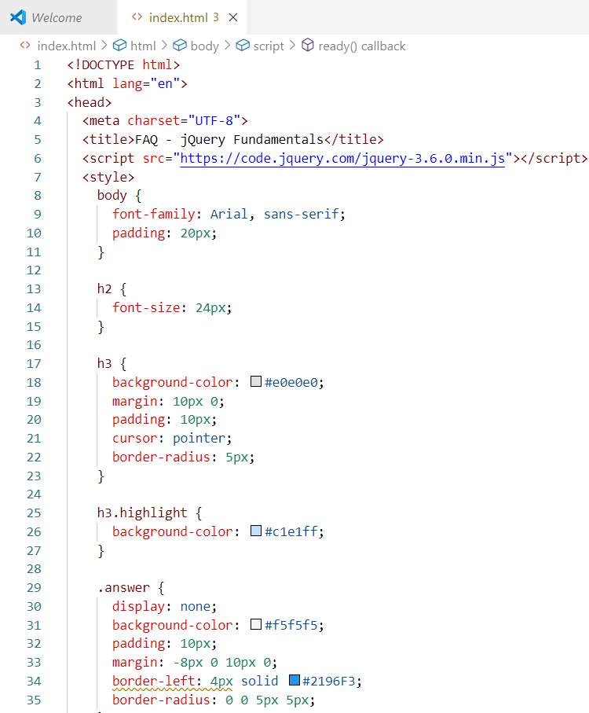

* 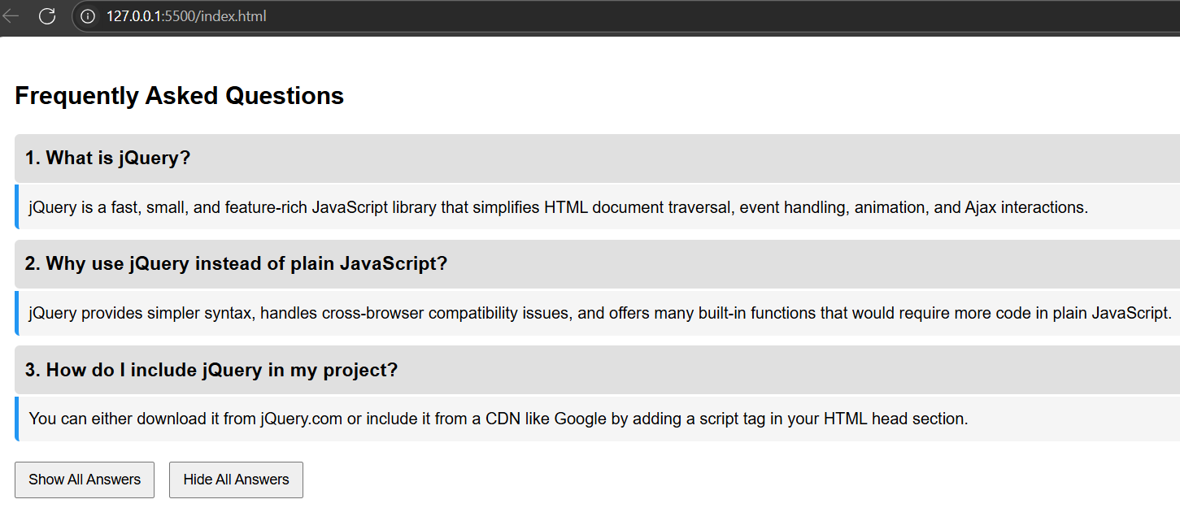**A screenshot of a computer

  AI-generated content may be incorrect.OUTPUT**

***WHAT I LEARNED IN THIS LAB:***

In this lab, I learned how to use jQuery selectors, events, and effects to create an interactive Frequently Asked Questions (FAQ) section on a webpage. I gained hands-on experience with the following concepts:

1. **jQuery Selectors:**I used class selectors (.question), ID selectors (#showAll, #hideAll), and element selectors to access and manipulate HTML elements.
2. **Event Handling**:  
   I applied click(), mouseenter(), and mouseleave() events to make the webpage interactive — allowing questions to toggle their answers and change styles on hover.
3. **jQuery Effects:**  
   I used animation effects like slideToggle(), slideDown(), and slideUp() to show or hide the answers smoothly, improving the user experience.
4. **DOM Traversal:**  
   I learned how to use the .next() method to target the answer directly following each question element.
5. **Document Ready Function:**  
   I ensured that all my jQuery code ran only after the document was fully loaded using $(document).ready().
6. **Dynamic Styling with CSS Classes:**  
   I learned how to dynamically add and remove CSS classes (addClass() and removeClass()) for visual effects like highlighting questions on hover.